*ARTIFICIAL INTELLIGENCE*

A

rtificial intelligence is a technology of computer science from which a system can work on its own being sensible enough. We already know that the computer science has turned this entire world into a small global village. And now, this science is making sensitive systems that can work like any human being. We have sense organs so we are sensible enough. But computer scientists also imagined a computer system to work like a human putting the set of instructions in it so that can work as if has sense organs like we, humans. These days, we can see people using automatic vehicles and voice recognisation softwares like siri in iphone and google assistant in latest android phones. These all are the examples of AI (Artificial Intelligence). It seems like scientists have put a servant for us in our pc or smart phones. 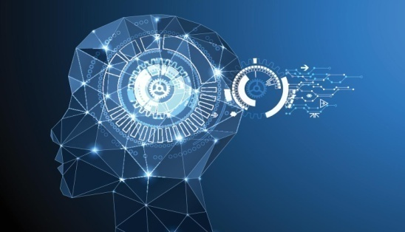

But there are more to come. Till now, only automatic personal cars were in vision. But now, china has developed automatic/electronic metro bus that can run without drivers. What technology is being used in it is actually, there is

color sensoring device at the bottom of the vehicle which traces and follows the white borders on the road and moves accordingly with respect of that borders.

Artificial intelligence (AI) is intelligence exhibited by machines. In computer science, the field of AI research defines itself as the study of "intelligent agents": any device that perceives its environment and takes actions that maximize its chance of success at some goal. Colloquially, the term "artificial intelligence" is applied when a machine mimics "cognitive" functions that humans associate with other human minds, such as "learning" and "problem solving".  
  
  
As machines become increasingly capable, mental facilities once thought to require intelligence are removed from the definition. For instance, optical character recognition is no longer perceived as an example of "artificial intelligence", having become a routine technology. Capabilities currently classified as AI include successfully understanding human speech, competing at a high level in strategic game systems (such as chess and Go), autonomous cars, intelligent routing in content delivery networks, military simulations, and interpreting complex data. In recent years, chatbot with artificial intelligence is also considered to be used for education.  
  
AI research is divided into subfields that focus on specific problems, approaches, the use of a particular tool, or towards satisfying particular applications.  
  
The central problems (or goals) of AI research include reasoning, knowledge, planning, learning, natural language processing (communication), perception and the ability to move and manipulate objects. General intelligence is among the field's long-term goals. Approaches include statistical methods, computational intelligence, and traditional symbolic AI. Many tools are used in AI, including versions of search and mathematical optimization, logic, methods based on probability and economics. The AI field draws upon computer science, mathematics, psychology, linguistics, philosophy, neuroscience, artificial psychology and many others.  
  
The field was founded on the claim that human intelligence "can be so precisely described that a machine can be made to simulate it". This raises philosophical arguments about the nature of the mind and the ethics of creating artificial beings endowed with human-like intelligence, issues which have been explored by myth, fiction and philosophy since antiquity. Some people also consider AI a danger to humanity if it progresses unabatedly. Attempts to create artificial intelligence have experienced many setbacks, including the ALPAC report of 1966, the abandonment of perceptrons in 1970, the Lighthill Report of 1973, the second AI winter 1987–1993 and the collapse of the Lisp machine market in 1987.  
  
*In the twenty-first century, AI techniques, both hard and soft, have experienced a resurgence following concurrent advances in computer power, sizes of training sets, and theoretical understanding, and AI techniques have become an essential part of the technology industry, helping to solve many challenging problems in computer science. Recent advancements in AI, and specifically in machine learning, have contributed to the growth of Autonomous Things such as drones and self-driving cars, becoming the main driver of innovation in the automotive industry.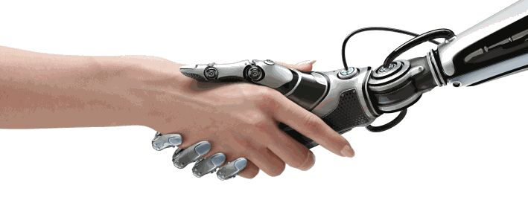*  
  
Now, let’s take a look at the History of artificial intelligence and Timeline of artificial intelligence.  
While thought-capable artificial beings appeared as storytelling devices in antiquity, the idea of actually trying to build a machine to perform useful reasoning may have begun with Ramon Llull (c. 1300 CE). With his Calculus ratiocinator, Gottfried Leibniz extended the concept of the calculating machine (Wilhelm Schickard engineered the first one around 1623), intending to perform operations on concepts rather than numbers.